# **Name: Abdurrahman Qureshi**

# **Roll No: 210451**

Practical No: 15

1. **Fibonacci using Sub-Procedures**

**CODE:**

Public Class Form1

Private Sub Button2_Click(sender As Object, e As EventArgs) Handles Button2.Click

TextBox1.Text = ""

ListBox1.Items.Clear()

End Sub

Private Sub Button1_Click(sender As Object, e As EventArgs) Handles Button1.Click

fibo()

End Sub

Sub fibo()

Dim n As Integer = Integer.Parse(TextBox1.Text)

Dim num1 As Integer = 0

Dim num2 As Integer = 1

Dim num3 As Integer = 0

ListBox1.Items.Add(num1)

ListBox1.Items.Add(num2)

For i As Integer = 3 To n

num3 = num1 + num2

ListBox1.Items.Add(num3)

num1 = num2

num2 = num3

Next

End Sub

End Class

**OUTPUT:**

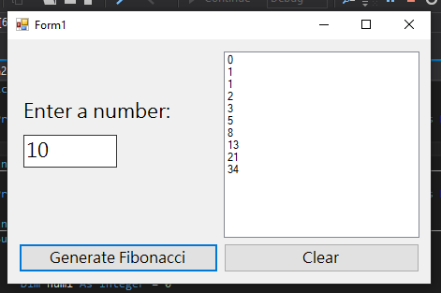

1. **Reverse of a number**

**CODE:**

Public Class EXP15SubReverse

Sub Rev()

Dim number As Integer = Integer.Parse(TextBox1.Text)

Dim reversedNumber As Integer = 0

While number > 0

reversedNumber = reversedNumber * 10 + number Mod 10

number = number \ 10

End While

Label2.Text = reversedNumber

Console.ReadLine()

End Sub

Private Sub Button1_Click(sender As Object, e As EventArgs) Handles Button1.Click

Rev()

End Sub

Private Sub Button2_Click(sender As Object, e As EventArgs) Handles Button2.Click

TextBox1.Text = ""

End Sub

End Class

**OUTPUT:**

